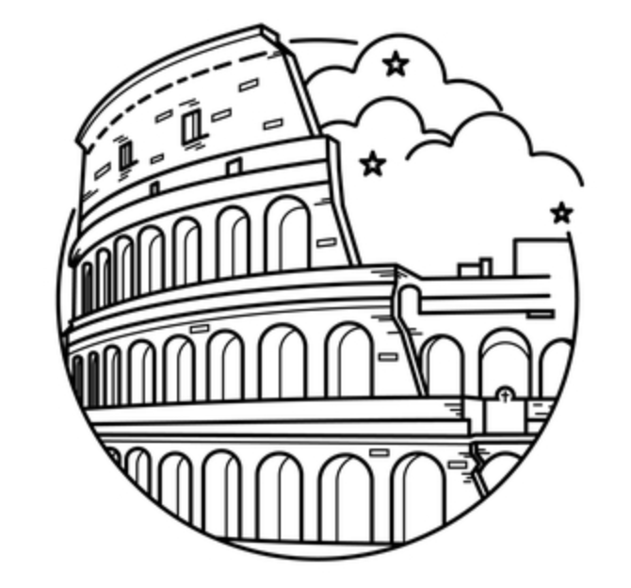**9 Strange and Gross Facts**

**About Ancient Rome**

1. The Romans Kept Things Clean and Spotless

Urine as it turns out was a very valuable commodity for the Romans because they found so many useful purposes for it. In fact jars were placed on the streets for people to pee in so that the urine would never go to waste. So why was it so valuable?

The soaps that we use today did not exist in ancient Rome. Lye was used by Romans to wash clothes but it was too expensive for the average Roman. Instead an affordable substitute was urine. Urine contains ammonia, a powerful cleaning agent. A vat was filled with togas and urine and a man stomped up and down in the vat cleaning the clothes. After the clothes were clean they were often rubbed with fragrant leaves to remove the smell.

That same cleaning power could be used to keep a Roman’s teeth white and bright, they used urine as a mouth rinse. A famous song from the period mocks those with white teeth:

*Or any washing teeth to shine o'er much,*

*Yet thy incessant grin I would not see,*

*For naught than laughter silly sillier be.*

*Thou Celtiber art, in Celtiberia born,*

*Where man who's urined therewith loves a-morn*

*His teeth and ruddy gums to scour and score;*

*So the more polisht are your teeth, the more*

*Argue they sipping stale in ampler store.*

1. Romas Kept Evil Away With Lucky Charms

Over time many items have been used as good luck charms, like rabbits feet, or four leaf clovers. The Romans, who were mortally afraid of evil were no exceptions to the rule. But they couldn’t be bothered with mere clovers, instead they went straight to the top of the pole and used phalluses to ward off evil. They made phalluses into necklaces, windchimes, and hung them over doors in order to ward off the evil spirits.

The practice came about from worshiping the deity Priapus who was a child of Venus and was known for having large genitals. He was also known to be very ugly and his image was supposed to scare off thieves. Somehow walls and doors went from being inscribed with his likeness to just an image of his genitals.

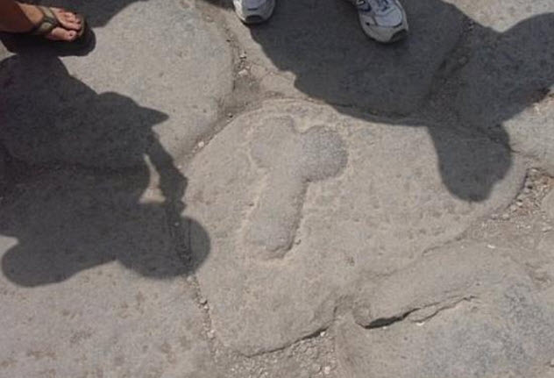

1. The Romans Executed Prisoners

We all know that the Romans used the colosseum for blood sports and with each show the Romans felt a need to top the last big colosseum spectacle. One way they did this was by putting criminals to death via sex with animals. The animals used included bulls, wild dogs, giraffes, and baboons.

1. Energy Boost

If you think energy drinks are an invention from the last several years you would be wrong. According to Pliny the Elder wild boar dung was applied to wounds, scraps, and bruises. Roman charioteers were especially fond of it, using it to heal wounds from the circuses. The potent healing properties were not limited to just wounds. Dried dung boiled with vinegar was considered a reviving tonic. Emperor Nero was known for using this tonic when his energy was flagging.

1. Another Source Of An Energy Boost

It seems that one could boost their energy in other ways. Romans were afraid of being stricken with ill health and vitality was important. One method to add vim to one's day was with the blood of dead gladiators. When gladiators entered the ring they were in the best shape of their lives. The thinking was that their blood could extend that vitality to others. The blood from dead gladiators was collected and sold as a cure for things like epilepsy. After a time Rome banned gladiatorial combat but the practice of drinking blood continued. When a prisoner was killed the blood was harvested and shared with those needing a boost.

1. It’s Hard To Look This Good

Roman women had to look their best. One reason for this was that a woman’s appearance was a reflection on her husband. Light skin was considered a mark of beauty because it was a symbol of the leisure class. In order to achieve this look of pale luxury women applied combinations of sulfur, chicken fat, eggs, and worst of all white lead. This toxic brew had the effect of eating away at the skin requiring more makeup. Red cheeks were also popular in the day. To achieve this Roman woman used red lead and cinnabar, a derivative of mercury to achieve a healthful glow. The problem was mercury exposure can cause tremors, confusion and death.

<https://allthatsinteresting.com/makeup-history>

1. A Trip To The Loo

Romans have received a lot of credit for their advances in hygiene. But it turns out they were not as advanced as once thought. While many homes had toilets Romans also used public toilets for life’s necessities. These toilets were rarely if ever cleaned, as a result they often had excrement and urine on the seats and floor. Once a Roman had taken care of business they used a sponge on a stick to clean their bums. The problem was that there was only one stick and everyone shared it. As a result of sharing this stick and the given the general state of the facilities lice and parasites were a big problem for the average Roman.

A Trip To The Loo Part Two

Roman toilets were dangerous for other reasons. These toilets were connected to a central sewer system which on its surface sounds like a good thing but as it turns out these sewers contained giant rats that could bite a person while using the toilet. Also when you collect a cities’ worth of waste you have the problem of gas building up. Roman toilets were known for catching on fire and worse, exploding.

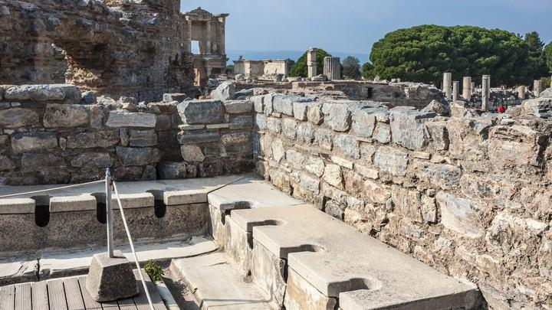

<https://listverse.com/2016/08/23/10-truly-disgusting-facts-about-roman-life/>

<https://www.theatlantic.com/health/archive/2016/01/ancient-roman-toilets-gross/423072/>

1. Using Poison To Extend Life.

Many Roman emperors knowingly poisoned themselves on a daily basis. They drank a concoction called mithridatium, which contained small amounts of known poisons, the hope was that it would eventually immunize them against poisons from an assassination attempt. As if that was not enough lead was used as sweetener for wine. Many believed that more than one Roman emperor went mad from ingesting too much wine.

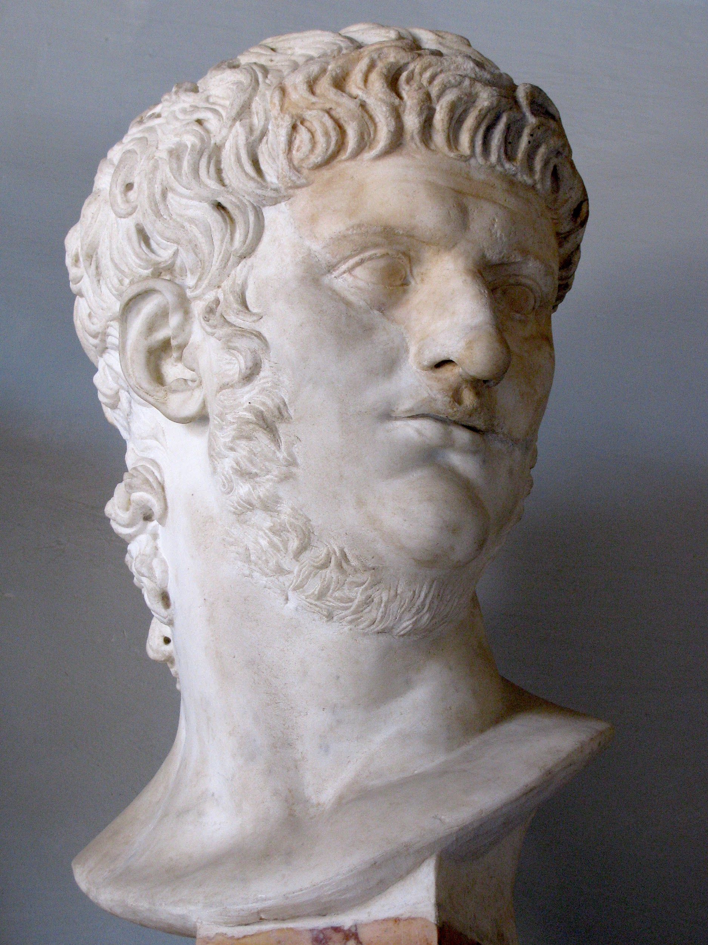

9. A Place to Puke.

Over the years a story was perpetuated that the Romans would throw lavish parties to display their wealth. Guests at these parties would eat till they were full and then go out back and vomit so they could eat again. Apparently there is no actual evidence that this took place. Instead a Roman at the time named the exit to the colosseum a vomitorium as a play on words. The colosseum was built with wide corridors which would allow a large number of people onto the streets in a short amount of time, thus the colosseum was vomiting up it’s patrons. The author Aldus Huxley, started the rumor in the ‘30s of a vomitorium being a place for purging a meal in order to return for more. So as it turns out ancient Rome was not that bad after all, at least there were no vomitoriums.

